**First Simple Spring Application-**

The following resources are required to build the first spring application.

Spring bean class (Java class)

Spring configuration files (.xml)

Client application (Java class with main method)-

**Internal working of Spring-**

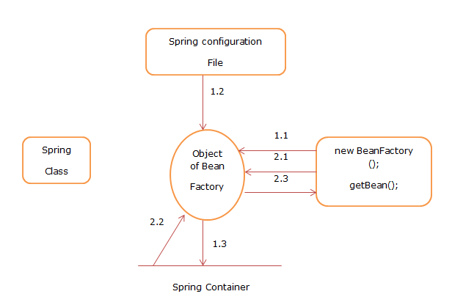

1.1 BeanFactory object is created.

1.2 Spring Configuration file is injected into bean factory object.

1.3 Spring bean (POJO) object created and stored into Spring/IOC container.

2.1 getBean () method is invoked.

2.2 get the spring bean object (Student class object)

2.3 Bean object provided to user program.

**Note** –

1. If we use ApplicationContext then it will create the object of ApplicationContext not BeanFactory.
2. We can mention named as spring.xml file or applicalicationcontext.xml.

**Folder structure of Spring Application.**

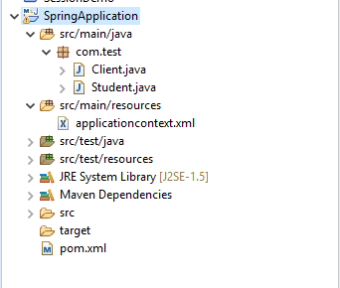

**Student.java**

**package** com.test;

**public** **class** Student {

**private** String firstname;

**private** String age;

**private** String city;

**public** String getFirstname() {

**return** firstname;

}

**public** **void** setFirstname(String firstname) {

**this**.firstname = firstname;

}

**public** String getAge() {

**return** age;

}

**public** **void** setAge(String age) {

**this**.age = age;

}

**public** String getCity() {

**return** city;

}

**public** **void** setCity(String city) {

**this**.city = city;

}

@Override

**public** String toString() {

**return** "Student [firstname=" + firstname + ", age=" + age + ", city=" + city + "]";

}

}

}

**Test.java**

**package** com.test;

**import** org.springframework.beans.factory.BeanFactory;

**import** org.springframework.beans.factory.xml.~~XmlBeanFactory~~;

**import** org.springframework.core.io.ClassPathResource;

**import** org.springframework.core.io.Resource;

**public** **class** Test {

**public** **static** **void** main(String[] args) {

ApplicationContext context=**new** ClassPathXmlApplicationContext("spring.xml");

Student student=(Student)context.getBean("s");

System.***out***.println("Student data>>"+student); }

}

**applicationContext.xml**

<?xml version=*"1.0"* encoding=*"UTF-8"*?>

<beans xmlns=*"http://www.springframework.org/schema/beans"*

xmlns:xsi=*"http://www.w3.org/2001/XMLSchema-instance"*

xsi:schemaLocation=*"http://www.springframework.org/schema/beans*

*http://www.springframework.org/schema/beans/spring-beans-2.5.xsd"*>

<bean id=*"s"* class=*"com.test.Student"*>

<property name=*"firstname"* value=*"ram"*></property>

<property name=*"age"* value=*"25"*></property>

<property name=*"city"* value=*"pune"*></property>

</bean>

</beans>

**Pom.xml**

<project xmlns=*"http://maven.apache.org/POM/4.0.0"*

xmlns:xsi=*"http://www.w3.org/2001/XMLSchema-instance"*

xsi:schemaLocation=*"http://maven.apache.org/POM/4.0.0 http://maven.apache.org/xsd/maven-4.0.0.xsd"*>

<modelVersion>4.0.0</modelVersion>

<groupId>spring</groupId>

<artifactId>SpringApplication</artifactId>

<version>0.0.1-SNAPSHOT</version>

<dependencies>

<dependency>

<groupId>org.springframework</groupId>

<artifactId>spring-core</artifactId>

<version>${spring.version}</version>

</dependency>

<dependency>

<groupId>org.springframework</groupId>

<artifactId>spring-context</artifactId>

<version>${spring.version}</version>

</dependency>

</dependencies>

<properties>

<spring.version>3.2.3.RELEASE</spring.version>

</properties>

</project>

**Output-**

Student data>>Student [firstname=ram, age=25, city=pune]